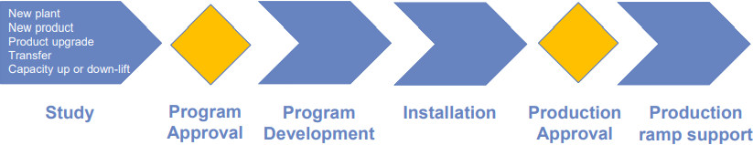**MANUFACTURING ENGINEERING PROGRAM**

***Study phase***

A complete ME Program is composed of **4 phases**, separated by two **Program Approvals**.

The first phase is the study phase. During this phase, the manufacturing engineers **analyze** and evaluate every single part that will be implemented in the final product, as to allow the **managers** to take the right decision about the investment, which will let the Company obtain the planned **income**. The study phase follows the **input/action/output methodology** and is divided into **four steps**, with every step using its predecessor’s output as an input:

* **Process cycle study**: the base input is the **BOM**, which gives also a **mechanical drawing** for each part number, and a **volume** to be produced for each year of the plan. During this step, engineers define types and numbers of **required machines**, the **required tools** and so on for each operation. In case of **manual assembly**, the operation is analyzed highlighting the **time** and the value or non-value added.

The **output** of this phase consists of all the **machines and tools** required, the **manpower time** needed and the machine **I/O status**;

* **Concept layer**: the goal of this step is to **synthesize** the process cycle with material flows and manpower distribution;
* **Plant engineering design**: this step uses the concept layout to define all the **buildings and utilities** (electricity, water, coolant system and so on) needed to production.
* **Economic evaluation**: it’s an economical summary to define two aspects:
* The **investment** to cover building, machinery and equipment necessary to **install** the required the production capacity;
* The full **transformation costs** due to the plant (including manpower, material and services).

Ath the end of the study phase, there’s the first **program approval**, where the whole is study is compared with other possible **alternatives** under a strategic point of view.

***Program Development and Installation***

Once the program has been approved, the tasks mentioned in the study have to be **defined** with major precision to **build** the machinery and implement. The main goals of these two phases are to:

* **Prepare** the building;
* **Design and install** machinery and equipment;
* **Train** the plant people to manage machinery and products;
* **Certify** the buy parts and logistic process.

These phases are once again followed by a **program approval**, which leads to the last phase: **production ramp support**.

**THE PRODUCTION MANAGEMENT THEORY**

***Pillars***

Before the introduction of machines in manufacturing, the production of general goods was based on human ability: this is called **handicraft period**. Nowadays, handicraft is confined almost exclusively to the luxury products, where the unicity plays an important role.

In 1911, Frederick Taylor issued the book “**The Principle of Scientific Management**”, which gave birth to the **Production Management theory**, also known as Taylorism.

Taylorism stands on three pillars: **scientific management**, **owner** and **employees**; on the basis of these three pillars, it builds its scientific approach to production:

* **Management must participate** on production beside the workers;
* **Precise analysis**, based on several parameters that need to be controlled and optimized;
* **Collection of data** is necessary to know and improve the process;
* An **optimized organization** takes to a better efficiency with cost reduction;
* The production phases must be regulated by a precise guideline called “**process cycle**”;
* Worker’s operations need to be **elementary**, in order to make the description easier, avoid the necessity of skilled people, increase volumes and reduce costs.

***Series production and manufacturing engineer***

Series production is based on Taylor’s idea of assigning workers the most elementary operations. This leads to the birth of some **coordination figures** above all workers, that decide who does what:

* The **manufacturing engineer**, that defines the **process cycle to** reach the required capacity, but also the tools, the equipment, the target time and so on;
* The **layout engineer**, who studies the **optimal equipment**, material and workers placement to execute the operations.

Below them, there’s the **plant staff** (workers and managers), who have the objective to execute the prescript process to reach the target.

**ASSEMBLY CYCLE**

***Manufacturing cycle***

It’s the first phase and is basically the description of sequence of technological operation, including tools, equipment and cycle time, aimed at the production of a specific component. The manufacturing cycle is based on three elements:

* **Bill of Process BOP**: sequenced process phases;
* **Bill of Materials**: structured list of parts and materials and relative quantity needed for each component and drawings;
* **Quality requirements**: standards and norms (cleanliness, traceability, handling).

**PRODUCTION CAPACITY AND EFFICIENCY**

***Production capacity***

To deal with the **estimates** of future demand from Marketing and planned production capacity of the Plant Machinery, there are some **ground rules** that involve different aspects:

* The variability of **demand**;
* The possibility to **adapt capacity**;
* The product and process **flexibility**;
* The **efficiency** and the effect of variability on it.

Production capacity is expressed in **thousand units per year** and is defined by dividing the work year into weeks, days (**280 days/year**, so **6300 hours/year**) and shifts; Italy uses the following standard:

* $shift=7.5 hours$;
* $day=3 shifts$;
* $week=6 days$.
* $year=46,7 weeks$.

The target production capacity is then used to evaluate the necessary **cycle time $CT$** , which is the **inverse of machine rate $r$** .

***Efficiency***

However, since the target production capacity is the net output, the machine capacity must be **higher** to compensate the **losses**: that’s why the concept of **efficiency** was introduced. There are two **main definitions** of machinery efficiency:

* **Availability**: $A=\frac{m_{f}}{m_{f}+m_{r}}$;
* **Overall Efficiency Line OLE or Operational Efficiency OPE**: $OLE=\frac{Actual Production*target cycle time}{Available time}$. It is the ratio between the **actual produced** **time**, evaluated **at the end** of a period to know the **exact target time** necessary to produce goods, and the **available time**, calculated by detracting all the **downtime** (like canteen time) from the total time (like 24 hrs.).

Efficiency is used to identify how much the line needs to be **accelerated** to have extra production, so to calculate a **more precise** machine rate: $r_{adj}=\frac{r}{eff}$ (where $eff$ is either $A$ or $OLE$). This “adjusted” value will be used to identify the **correct cycle time**; being cycle time the inverse of machine rate, it can be also calculated as $CT=\frac{1}{r_{adj}}=\frac{eff}{r}$.

***Production profile per operation***

Since each operation si **different**, the only possibility is to ensure that all the operations of a line have a cycle time that is **smaller or equal** to the target. To be more precise, a production profile per operation can be obtained by combining **efficiency per operation** and **cycle time per operation**, $P\left(i\right)=\frac{eff\left(i\right)}{CT\left(i\right)}$, where:

* $P\left(i\right)$ is the **expected production** of the operation $i$;
* $eff\left(i\right)$ is the **calculated efficiency** of the operation $i$.

***Simulation***

Efficiency is a **data given** experience, that’s why **simulation tools** are used in order to predict it; if operations were independent, the overall efficiency would be the one of the **bottleneck operations**, but since there are a lot of **interferences** between them, the actual efficiency is **lower** than the bottleneck’s.

In general, the **assembly designer** proposes a line with certain transport and warehouse dimensions that are **tested** through a simulation, creating an **iterative process** that ends when a **satisfactory result** has been reached in terms of efficiency forecast.

There are two simulation tools: **discrete** **events** and **analytic**. They are mainly **equivalent**, but the first is more precise if an **intelligent logic of management** system is introduced into the tool.

**PROJECT MANAGEMENT**

***Gantt diagram***

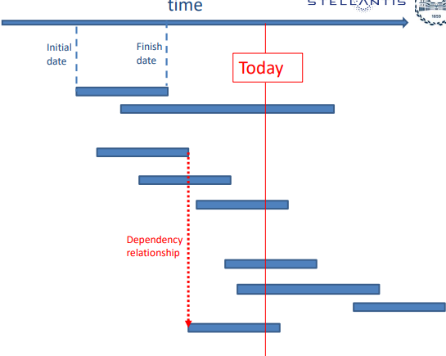At the end of XIX century, some huge infrastructures were built with a **different conception** than before: they were not meant to represent the **power** of a sovran (like the Pyramids), but they were intended to generate an **economical return** (like network of rails or dams). Between 1910 and 1915, engineer Henry Gantt developed a tool for project management for the construction of the Hoover Dam; this tool was named after him – **Gantt diagram** – and laid the foundation for **scientific management**.

A Gantt diagram is a **bar chart** that illustrates the **evolution** of a project schedule, split in his **elementary phases**, the **dependency** relationships between activities and the **current status**. More specifically:

* The **tasks** to be performed are listed on the **vertical** axis;
* The **time intervals** are on the **horizontal axis**, showing the start and finish dates of the tasks;
* The **current schedule** status is shown using percent-complete **shadings** and a vertical “today” line.

The most difficult part when building a Gantt diagram, is to split a program in elementary phases to create the so-called **Work Breakdown Structure WBS** of the project; the WBS is used not only to organize the whole work itself, but also to manage the **investment** related to the plan: identifying each activity means defining the structure of the **purchasing process**.

**PRODUCT DEVELOPMENT PROCESS**

***What, how and why***

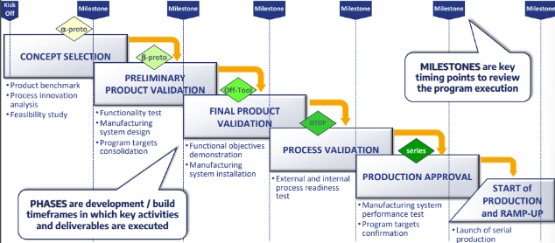Product Development Process PDP is a **project management tool** that defines the **methodology** to execute an automotive system program from concept to market; specifically, it plans and monitors the **development** of the product as well as the **manufacturing** **process**.

To do so, it specifies the **works** to be done, **when** they have to be completed and the way to **measure** the results; it also defines **rules and governance** and **tasks ownership**. As a matter of fact, the company **Leadership Team** endorses the PDP and governs the program execution in order to ensure it is launched consistently with **business** **requirements** and **customer satisfaction** targets. Governance is structured on **two levels**:

* **Managerial**: it deals with **topical technical and financial review** of program status, **risk managements** and so on. This level bases its decisions on **Key Performance Indicators KPIs**, quantifiable **measures of performances** over time for a specific objective, useful to provide **new targets** and to track **progress** towards achieving old targets;
* **Operative**: it focuses on **monitoring** the day-by-day activities on a **weekly** basis, as well as **planning** the next ones. The operative level bases its analysis on **outputs** and **deliverables**.

**POWERTRAIN TECHNOLOGIES**

***Powertrain assembly***

Assembly is one of the **most common** activities in a factory. It is a **reversible process**, as it doesn’t change the state of the assembled parts, and it’s normally **sequential** (either **automatic** or **manual**).

Apart from the basic technologies like loading and handling, the two specific technologies for assembly are **tightening** – based on the **stress/strain diagram** – and **inserting with pression**.

During the assembly process, several **tests** are taken, like **mechanical** tests, **leak** tests or **electric** tests; at the end there are two main **inspection systems**, **cold test** and **hot test** (with or without braking system).

***Powertrain machining***

Machining is a process during which **metallic** parts are **cut** in order to obtain a certain **shape** from a raw component. There are **two classes** of metal cutting:

* **Prismatic**: the **part is fixed** on a fixture and the **tool** is mounted onto a **spindle** and is **rotating**;
* **Rotating**: the **part is rotating** and the tool is mounted on a **tower** and is just **slowly moving** to advance.

The **terminology** used is the following:

* **Cutting tool**: the part of the machine **in contact** with the part;
* **Cutting chip**: the **excess of material** that has to be removed. It is **thicker** and **tougher** than the original material and it needs to be **controlled** in order to improve the **surface** quality and the **cleanness** of the part;
* **Reak angle**: the angle between the **cutting tool** and the **original surface**;
* **Coolants**: fluids used in order to **reduce the heat** caused by the cutting and maintain the **temperature** of the part inside an acceptable range.

The main machining **operations** are:

* **Turning**: the cutting tool – with a **single cutting edge** – is used to remove material from a **rotating** **workpiece** to generate a **cylindrical shape**. The **primary motion** is provided by rotating the **workpiece** and the **feed motion** is achieved by moving the **cutting tool** along the **parallel axis** of rotation of the **workpiece**;
* **Drilling**: the tool – called drill – is equipped with **two/four helical cutting edges** and moves **along** its own axis of rotation to a **round hole** inside the part;
* **Boring**: a finishing operation, a rotating tool with a **single pointed tip** is advanced into a **hole** inside the workpiece to **enlarge** it and improve its **accuracy**;
* **Milling**: a **rotating tool** equipped with **multiple cutting edges** is used to generate a **plain or straight surface**; the direction of the **feed motion** is **perpendicular** to tool’s rotation axis.

Auxiliary equipment for machining operation is required are **measurements** (achieved with gauges and 3D machines), **washing** and **coolant filtration systems**.

**THE MASS PRODUCTION**

***Fordism***

In the early 1900s, Henry Ford gave birth to a new **manufacturing technology** that went on to be the basis of modern economic systems in industrialized and standardized mass production: **Fordism**; it was designed to produce **huge volumes** of **standardized**, **low-cost goods** and afford its workers’ **wages** decent enough to **buy** them.

In order to produce high quantity of goods, Ford transformed the traditional **job shop** structure – where every operation is executed by a **specialized** **worker** – into a **flow layout**, where the whole production process is left to **special purpose machines**, leaving workers – that don’t require any specialization anymore – responsible only for the **assembly process**.

***The transfer lines***

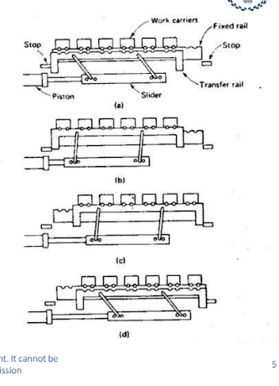The most used special purpose machine is the **transfer line**: in each operation, a **multi-spindle head** – driven by a gear box (with no CNC) and designed to do a **unique task** – executes the work through **fast advance movements** (slow during cutting).

The transfer line is made up of a “**walking beam**”, a lift and a translate rail that **moves** the part from station to station. The handling is divided into **four phases**:

* **Carrying**: the piece is carried to its station by **work carriers**;
* **Lift-up**: the piece is **freed** from its fixture;
* **Translation**: the piece is carried to the **next station**;
* **Engaging**: the piece is **moved down** to engage the pins of the next work position.

The **cycle time** is defined by the time between two **successive bar transfers**.

***The synchronous assembly lines***

It’s a line where all the workers do their respective jobs at the **same time**. Each worker is assigned to a **specific** **position** where he does his task, while the **materials** are moving **over** or **under** him; the materials **to be** **assembled** are usually located **behind** the worker. The **cycle time** is $CT=\frac{d}{v}$, where $d$ is the distance between two products and $v$ is line speed.

***Evaluation of mass production technology and social influences***

The synchronous assembly line determined the **success** of mass production systems and was used in its original form until **1960**:

* **Pros**: it offered high **productivity** and high **reliability**, thanks to great **standardization** due to the **simplicity** of the operations;
* **Cons**: it caused **stress** to workers and required a **high** **investment** for building the multi-spindle heads and for handling any kind of **diversification** to the final product.

The synchronous line made it possible for workers to become **consumers**; at the same time, however, workers did only **elementary operations** and never saw the **final product**: this caused alienation and the whole system was judged as **inhuman**. This general **unsatisfaction** of the worker class brought to a period of **strikes** and **conflict** between workers and employers. To face this problem, manufacturing engineers started working together with **psychologists** and **sociologists** and investigated in two different directions:

* Switch from series to **parallel work**, so as to put **together** workers and avoid the alienating conditions;
* Introduce **robots** to complete the heavy and **repetitive work** and leaves workers to **coordinate** and **maintain** the machines.

**IN ITALY**

Engineer **Adriano Olivetti** was very attentive to the **relationship** between factory and workers conditions; basically, his thought was based on **two pillars**: the **integration** between factory and city life and the **future** **of information technology**. For this reason, he employed **free minded** people from any field to work in a **de-structured way**, creating the first advanced **computer technology company** in Europe (in 1960). Moreover, to pursue his goal of improving workers’ life, he created a center of **psychological research** and introduced the **Manufacturing Integrated Unit UMI**: a group of workers responsible for the **quantity** and the **quality** of the final product.

***Asynchronous groups and Fanuc***

They are two system that were born from the **two** **approaches** to the improvement of workers’ condition inside the factory.

**ASYNCHRONOUS GROUPS**

They were defined by elaborating the UMIs in the **automotive field** and became a standard in the Fiat factories. The asynchronous group is a **parallel line** where:

* Workers have not rigid constrains and their only **restriction** is to guarantee an **average cycle time**;
* Workers develop **more relation** with the final product (not so much to become craftsmen, but more than an unskilled worker).

Due to the complexity of the automotive products, a single asynchronous group was not enough; this is why these groups started to be organized in **series** – divided by **buffers** to compensate the different speeds of the groups – with every group including from **6 to 18 workers.**

**HIGH AUTOMATION**

In Japan, Fanuc engineer Seiuemon Inaba (like Olivetti, he also believed in integration between factory and cities) focused his attention on the way **computers** can **support** the manufacturing: **CNC and robotics**. Inaba built factories where workers could **live** in, and started producing **robots** to be implemented **inside** the Fanuc manufacturing processes and to be **sold** to other companies. This assembly model is based on:

* **Product conceived to be assembled by a robot**;
* **Component selected to avoid jamming and breakdown**;
* **Avoiding set-up activities**.

Products to be assembled are located on a **pallet** where a **magnetic tag** (RFID) allows to write all the **necessary** **features** and to acquire the **history**; this information is **maintained** along the line and is then uploaded to a **central computer**.

**FLEXIBILITY**

***History and definition***

during the 80s consumers started to demand **variations** for the same products (like different features for the same vehicle), so flexibility started to be a very important goal for automotive companies. This problem could be solved only with the support of **information technology**: the transfer line model was being challenged and the **CNC machining center**, a new concept machine (that used the **parallel model**), was introduced.

Flexibility can be defined as the **ability** to work in an assigned field of the productive mix with **medium costs** of production and **conversion** in case of **new needs** from the market. To pursue flexibility means also to pursue:

* **Adaptability**: to produce and commercialize **different products** with the **same machinery** limiting costs;
* **Convertibility**: capability to **modify the plant** in order to reuse it for a new production;
* **Versatility**: control **burden costs** by modifying the **product mix** (from a lighter to a heavier model or vice versa);
* **Elasticity**: absorb negative or positive **demand variations** without an unbearable increase of the unit costs.

***CNC machining center***

It is a CNC machining tool that can perform **several operations** (like milling, drilling and so on) with high accuracy and minimal time. It consists of:

* A **spindle** that moves in the work area to execute operations;
* An **automatic** **tool-changing mechanism** that allows to us multiple cutting tools during the machining process;
* A table with **pallet** and **fixture** to keep the parts in a specific position.

To calculate movement and positioning, the computer uses **five axes**: $\vec{x}$ (horizontal), $\vec{y}$ (vertical), $\vec{z}$ (spindle rotation), $\vec{A}$ (rotation around $\vec{x}$) and $\vec{B}$ (rotation around $\vec{y}$).

The AT Kearney law, $\sum_{i}^{N}{q_{i}t_{i}}=TM$, where:

* $T$ is the considered time;
* $M$ is the number of spindles;
* $q_{i}$ is the quantity of the part $i$ to be produced in time $T$;
* $t_{i}$ is the machine time of part $i$;
* $N$ is the number of parts.

With $T_{f}=\frac{\sum_{i}^{N}{q_{i}t_{i}}}{\sum_{i}^{N}{q_{i}}}$ (average weighted time of parts of the same family) and $Q=\frac{\sum_{i}^{N}{q_{i}}}{N}$, we have $QN=\frac{TM}{T_{f}}$.

***Flexible manufacturing system FMS***

It consists of **several** CNC machining tools equipped with a **work piece** and **tool charge handling device**, a **work piece store**, automatic **control and supervision** by a central computer; it can be integrated with automatic **cleaning**, **deburring**, **inspection** and – if necessary – **manual operations**.

Gradually MCs **replaced** the job shops in manufacturing and, although the first attempts of connecting different CNCs were not successful (due to the complex technology required), at the end of the 90s **huge lines** of several MCs were introduced; this allowed companies to gain **convertibility** and **elasticity** (nowadays, the term FMS has been replaced by **CNC automatic line**).

***Series vs parallel efficiency***

Being the efficiency $E=\frac{EWT}{TT}=\frac{TT-BR}{TT}$, we have:

* **Series**: there’s production only if **all machines** are running so to calculate $TT-BR$ we need to detract $BR_{i}$ and the **overlapping** of $BR_{i}$ from the total time. In terms of probability $BR_{i}=1-E_{i}$ and $overlap=\prod_{i}{\left(1-BR_{i}\right)}$. At the end, we have $E_{S}=\prod_{i}{E_{i}}$;
* **Parallel**: there’s no need for all the machines to run to have production, so $TT=nTT$ ( $n$ being the number of machines) and $EWT=E_{i}TT$. At the end, we have $E_{P}=\frac{\sum_{i}{E_{i}}}{2}$.

Despite the parallel line being more efficient than the series, the have different **pros**:

* **Series**: it is **cheaper** (it requires simpler operations), **easier to manage** (technology is distributed along the line and it’s possible to specialize tracks) and it has **simpler flows**;
* **Parallel**: it has a **higher efficiency** (breakdowns have less influence, since machines keep working if not affected) and **more flexibility**.

**QUEUING THEORY**

***Definition and general aspects***

The queuing theory studies the phenomena happening **between** the customer arrival and the service; it consists of **three fields** of study:

* **Open stationary systems** made of **infinite customers** with an arrival rate **minor** than the service rate;
* **Closed stationary systems** consisting of a **finite number** of customers (most of manufacturing systems);
* **Dynamic systems**.

***Little’s law and main functions***

A very important pillar of the queuing theory is Little’s law, $P=\frac{W}{T}$:

* $W$ is the average number of **customers** or $WIP$;
* $P$ is the average **arrival** **rate** or $TH$;
* $T$ is the average **time** that a customer spends in the system.

The importance of this law is due to the fact that this relationship is **very little affected** by any kind of factor (like process or service distribution).

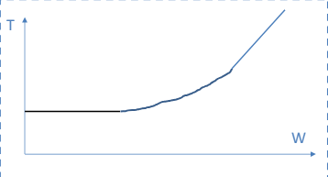The main functions in queuing theory are $T\left(W\right)$ and $P\left(W\right)$.

$$T\left(W\right)$$

There are three main areas that can be evaluated:

* **Low $W$** : time is constant and is the sum of technical time and cycle time;
* **High $W$** : time grows linearly with the customers;
* 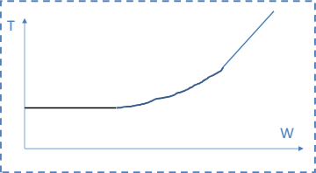**Middle area**: its behavior is studied by the queuing theory.

$$P\left(W\right)$$

There are three main areas that can be evaluated:

* **Low $W$** : the throughput grows linearly;
* **High $W$** : the throughput stops growing and is constant;
* **Middle area**: its behavior is studied by the queuing theory.

Its behavior follows the relationship $P\left(W\right)=\frac{W}{T\left(W\right)}$.

***Open system/single server***

It is indicated with the notation $M/M/1/∞$, so this system is characterized by:

* Infinite customers with arrival rate $λ$ (Poisson’s law);
* Single service with service rate $μ$ (Poisson’s law).

Being $λ<μ$, we have:

* **Probability that there is no queue**: $p=1-\frac{λ}{μ}$;
* **Average time a customer spends in the system**: $T=\frac{1}{μ-λ}$;
* **Average time a customer waits in the queue**: $T_{q}=\frac{λ}{μ\left(μ-λ\right)}$;
* **Average length of the queue**: $W_{q}=λT_{q}$.

***Closed system/multiple server***

RIVEDI

***Conclusions***

Besides the several formulas, it’s important to know that:

* $M/M/1/∞$ system can be used for services with **high number of customers**;
* $M/M/S/∞$ is usually **not used** because it is shorter;
* $M/M/S/N$ has a large range of application in **building** and **utilities design**;
* **None** of the open systems can work for a **closed system**;
* There are some **iterative algorithms** that can reach a good level of approximation, but the best way is to use **simulation** with a better definition of the statistics.

***Nonstationary system***

It’s a system that faces a moment in which it is **open** but a **non-constant rate**; then it behaves like a **closed** **system** and it has **few arrivals**; finally, there’s a second **rush time**.

**LOGISTICS AND FLEXIBILITY**

***The crisis of the traditional logistic systems***

The success of the new flexible offer caused **huge** **problems** in terms of internal logistics. As a matter of fact, while during Fordism era there was one manufacturing volume for each product, one list of components for each product and one destination for each component, now there were **different manufacturing volumes**, as well as **different lists of components** (from then on called Bill of Materials BOM), **different destinations** for each component and **different work operations** for each man, robot or machine.

The whole logistic system was to be reinvented, so the problem was split into **three subproblems**:

* **Physical transport** of good or finished product from plant to plant;
* **Optimal packaging strategy**;
* **Internal logistics** (handling, warehouse and distribution logic to the line sides).

The problem was approached following Pareto law and ABC analysis, both of which are still used to set priorities to approach complex problems and set **priorities**.

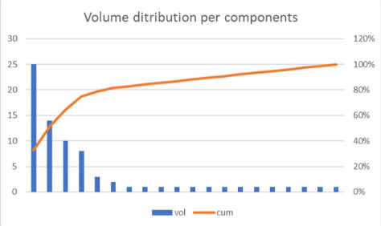***Pareto law***

The problem was approached following the Pareto principle, according to which **the 80% of an achievement is generated by the 20% of its causes and vice versa**. Almost any problem can, in fact, be described with a **diagram** of Pareto, which shows the **cumulate percentage** of the population starting from the most important element to the least.

***ABC analysis***

It is a statistical analysis that consists in **splitting** the analyzed objects into **three categories**, according to their impact to the business:

* **Group A**: this group contains those items with the **highest annual consumption value**, so that need to be **frequently reordered** to guarantee a good supply. This group can also contain items with **considerable physical dimensions**, which need specific warehouses and a focused handling system;
* **Group B**: this group contains those items with a **consumption value** in the **15-20% range**;
* **Group C**: this group contains item with the **lowest consumption value** that should **rarely be reordered** because of their high running costs.

Some **classification criteria** for the ABC analysis could be:

* **Group A**: products with **big dimensions** and high **number of variants**, because the occupy a big part of the line and must arrive to the right place according to a specific plan;
* **Group B**: component in class require all types present or medium part can be considered all present but in limited quantity and creating a complex handling material;
* **Group C**: the smallest parts can be all present but in quantity to minimize handling.

***Kitting***

In a **synchronous** line, each position had a **single operation** to be done with a **specific material** to be dispatched, so it was easy to feed. Same can’t be said for an asynchronous line, which to be fed required the introduction of **kitting**: each position received a **kit** containing the **product** and the **components**; this solution work **perfectly** with **class B** components, while **class A** products were assembled in **specific stations** first – due to their dimensions – and then completely assembled **inside** the asynchronous groups.

**PLANNING AND SCHEDULING**

***Planning in automotive***

In automotive, the development of the **long-range plan** (5 to 10 years) is done **yearly** with **monthly updates**. It is deployed for all production plants and includes first a **vision** of the product, then an **analysis** of demand evolution vs available capacity, then a **multiple scenarios comparison** and finally a **plan of investment** that will represent the fund to cover the following initiative.

Limiting to demand, the **plant organization** is based on an **operative plan** with an 18-months vision updated monthly as well; during the updates, the vehicle demand is submitted to **bottleneck analysis**. On the other hand, **powertrain** **plan** is affected by **daily variation**.

***Capacity planning***

Capacity planning is realized with **linear programming**, an algorithm that returns an **optimal solution**; an LP problem can be described with the **minimization** of an **objective linear function** submitted to one or more **linear constraints**. Capacity planning has two goals:

* 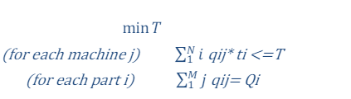**First goal**: obtaining the selection of the **maximum production feasible** in the line horizon (normally one week);
* 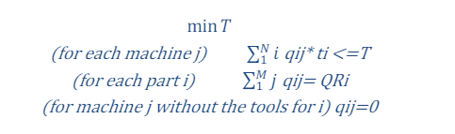**Second goal**: the line horizontal is **reduced** (normally one shift) and sliced into $QR_{i}$ and, for each slice, the LP problem defines the **optimal tool configuration**, enabling $q_{ij}>0$ for the machines with right tool for the part $i$.

***Scheduling***

Scheduling has the goal of defining the **optimal order of production** while respecting certain rules given by the plan. The most general scheduling **principle** is based on giving priority to the **shortest tasks** in order to satisfy a larger part of customers; however, this principle **cannot be used** in modern FMSs, so an algorithm was formulated.

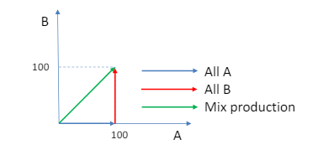**MIX PRODUCTION**

The algorithm is based on a general law: **a cumulated production aligned to the final mix minimizes the inter-operational stock**. In other words, if a product P is made of one piece of A and one piece of B, producing **completely** either one of the components will result in having a **100%** stock before actually delivering P; by producing both A and B at the **same time**, the stock is always 0, instead.

So, to guarantee mix production in a mix of $N$ components, it its necessary to select the part $i$ that **minimizes** **the distance** from the optimal mix, represented by a **line** that connects the origin with a target point $T\left(A,B\right)$. For any next part to be produced, we have $D\left(i\right)=\sqrt{{\left(\frac{q_{1}}{q_{tot}}-m_{1}\right)}^{2}+…+{\left(\frac{q_{i}}{q_{tot}}-m_{i}\right)}^{2}+…+{\left(\frac{q_{n}}{q_{tot}}-m_{n}\right)}^{2}}$, where:

* $q_{i}$ is the quantity of the part $i$ already produced;
* $q_{tot}=\sum_{1}^{N}{q_{i}}$;
* $T\left(i\right)$ is the production target of the part $i$;
* $m_{i}=T\left(i\right)/\sum_{1}^{N}{T_{i}}$ is the fraction of the mix.

**LEAN MANUFACTURING**

***The rise and fall of mass production***

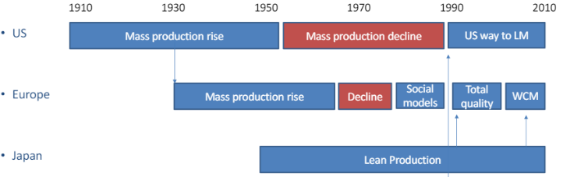During the golden era of mass production, there were two **main approaches** followed by American companies: Ford focused on **verticalization** and **self-banking** and General Motors focused more on **delegating** several **smaller companies** to different parts of its products while also **joining a bank** to have the necessary capital and financial services.

Although the mass production system was **not primitive** at all and contributed to **increase the welfare** of the workers, after a long period of growth it started to **decline** more and more until the beginning of the 90s. During this period, the American market was hardly hit by the Japanese production system: the **lean production system**.

***The birth of lean production***

At first, lean production was the name of the **Toyota Productive System**, but gradually spread to all Japan. The **birth** of lean production can be dated to the years **following WWII**; during this period, Toyota was facing a hard **crisis** and had to fire a lot of workers, causing several strikes. To solve the quarrel:

* Kiichiro Toyoda **retired** and assumed the **responsibility**;
* **25%** of the workers was **fired**;
* The remaining workers got **lifetime employment** and other benefits and rights.

This led to the birth of a **trustful** **relationship** between employers and employees, which was **unimaginable** for the western production system.

Furthermore, during those years Toyota had very **limited resources**. For this reason, inspired by Fordism, Eiji Toyoda (Kiichiro’s nephew) had to solve **two main problems**: dealing with the **stamping process** – which in mass production system took a **long die change** and a sophisticated **process of setup** – and to reduce the **initial investment**. The problem was formulated as “to find a way to produce small batches in one single press minimizing the changeover”; they managed to reduce it from days to three minutes, so the system was named **Single Minute Exchange Die SMED**.

Besides employer/employees’ agreement and batch reduction, Toyota engineers understood the importance of increasing **efficiency and quality**, in order to make the process **as regular as possible** (even by **slowing** **down** or reducing line saturation). In western companies, quality control was done by **specialized workers**, while in lean production workers were **directly responsible** for it, and were guided by a team expert.

Japanese Production System implemented a **trustful relationship** with **suppliers** too, for example acting like a **bank** by financing their investments; this allowed suppliers to plan **global improvements** and Toyota to **reduce supplies’ stock** (and costs) as well as **work in progress**.

***Elements of lean manufacturing***

**ECONOMIC ORDER QUANTITY VS BATCH = 1**

Economic order quantity, a metric that represents the **ideal order size** to minimize costs for the business: $Q=\sqrt{\frac{2AD}{h}}$ 
, with:

* $A$**cost of setup per unit**, which annually is $A_{A}=A\frac{D}{Q}$;
* $D$**annual demand**;
* $h$**holding cost per unit**, which annually is $h_{A}=h\frac{Q}{2}$.

Toyota tried a completely different approach to this methodology and developed the **batch = 1** **system**; this approach is based on **three assumptions**:

* The **tools** required by machines are **always available**;
* Necessary programs, tools and components for **assembly** are **available** in the **line** **side**;
* For **complex machines** and stamping we have $A=\frac{h}{2D}$.

This approach requires to produce according to the **final mix target** and with the minimum inter-operational stock.

**TOTAL QUALITY CONTROL**

Although it was developed by an American engineer and an American professor, total quality control was never fully used by western companies. The goal of the total quality control was to reach **perfection** through a tension towards **continuous improvement**. The basic principles of total quality control are:

* **Process control** for every single operation;
* **Quality easy-to-see**: the quality progress must be **easily understandable**;
* **Rigorous respect of specification**;
* **Stop of the line**: in order to solve quality issues immediately, automatic checks or “**poka-yoke**” techniques are used to **stop** the line;
* **Self-repairing**: the worker who detects an issue has to **repair it himself**, as to avoid the proliferation;
* **100% control**;
* **Improvement by project**: strategy is organic and structured.

These principles must be supported by **small batches**, **cleanness** and **order** in the workplace, planning for **less** **than full saturation** and **daily check** for the machines.

**PUSH SYSTEM VS PULL SYSTEM**

Since the 60s, supply chain systems – supported by computers – have been developed under the name of **Material Requirements Planning** **MRP**, which fulfills the following task:

* The definition of **net requirement** of existing stock;
* The **lead time** to launch production;
* The **components** and **raw part** needed according to production orders and BOM.

The MRP and its following versions are called **push systems**, because material are pushed along the line according to the **production plan**.

Push systems focus on stocks only at the end of period, so they don’t consider the fact that, in case of **lower** **demand**, stock could **increase uncontrollably**. For this reason, Japanese companies introduced the so-called **pull systems**: instead of basing their production on a plan, they based it on **customer demand**, in order to **reduce stock** at the end of every period.

**JUST IN TIME**

To create a pull system, a **complete control** on the production progress is required. Per the Little’s law $LT=WIP*TH$  
, so in order to ensure a short delivery time, the WIP level must be low. When the JIT system was developed, Japanese companies didn’t have enough money to buy **big computers**, so the introduced the **Kanban system**:

* For each line or department, materials are joint with a **card** (Kanban) – which are **limited** in number – and is **freed** once it’s been **delivered** to the customer, enabling a new **supply**;
* Every line or department creates a **link** with the **suppliers** to have a new material batch in a **predefined time**.

**ECONOMICAL EVALUATION**

***The business case method***

To evaluate all the different solutions proposed by Planning, Strategy and Engineering, companies use the **business case method**, which is more of a **conceptual model** that applies differently to every case than a universal method. The **execution** of a business case is done as follows:

* **Segregate** a part of the company that includes all the **factors** in some way **impacted** by the study (like a plant or a single line of a plant);
* For each scenario, define the **product portfolio** with related costs and revenues and develop it in the following **3 to 10 years**, to compare the results;
* Consider the effect of **inflation** and the **financial cost** of the business, including the weighted cost of capital.

***Types of application***

The main applications for a business study are:

* **Business unit**: it is used to evaluate the **financial sustainability** considering the **costs** according to the **selected scenario** and the **revenues** according to the **contract**;
* **New initiative**: it is used to evaluate the cost of **developing** without considering the **sales** in any scenario;
* **Make or buy**: it is used to evaluate the **investment** and the **variable cost** of producing a product internally rather than externally.

**MAKE OR BUY BUSINESS CASE**

It has the following parameters: **demand per year**, **investment** required buy **internal production**, **internal** **transformation cost**, **vendor tooling buy**, **buy price**. The make proposal is then evaluated by comparing the **NPV** at the end of demand with the **total investment** **actualized** to the first year; the **ratio** between the two is called **profitability**: if the profitability of the make proposal **matches** the company standard, it can be accepted.

**WORLD CLASS MANUFACTURING**

***WCM principles***

Its principles are those of lean manufacturing: **workplace organization**, **quality**, **maintenance** and **logistics**. These pillars are concentrated into **four goals** respectively:

* **Zero wastes**: achievable through **total industrial engineering**;
* **Zero defects**: achievable through **total quality control**;
* **Zero breakdowns**: achievable through **total productive maintenance**;
* **Zero inventory**: achievable through **just in time methodology**.

To sum up, WCM is not a way to support business, but it’s a way to actually **do business** and do manufacturing,

***WCM pillars***

Following WCM implies being **flexible**, **simple**, **rigorous**, **powerful** and **people-involving**. WCM methodology is based on **ten technical pillars** and **ten managerial pillars** (like clarity of objectives, commitment and competence). For each technical pillar, WCM follows a **7-steps approach**, which gradually change from **reactive** to **preventive** and then to **proactive** over time. This methodology is first implemented in a **model** **area** and then extended **plant wide** (starting from the **most critical** **area** to the least).

**HEALTH AND SAFETY**

Safety priorities are classified according to a **pyramidal scheme**: at the **base** there the **unsafe acts and conditions**, in the **middle** there are **near** **misses** and at the **top** there are **accidents**.

**COST DEPLOYMENT**

It is a methodology used to establish scientifically a cost reduction program and is based on these three different concepts:

* **Cost**: it’s a **useful outcome**, like paying a **maintenance** **company** to avoid machines from breaking;
* **Loss**: it’s a **useless outcome** (like the **missed income** due to a breakdown) or the **ineffective** **use** of an input;
* ***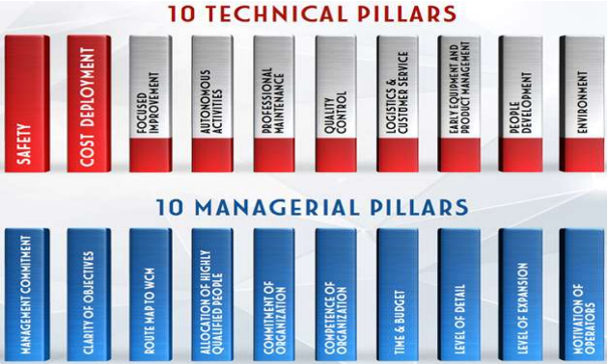*Waste**: it’s the **excess of amount** of an input.

Cost deployment follows a **structured approach**, and can basically divided into **two main phases**. During the first phase, the **main losses** are identified together with their **causes** and their **amount**; during the second phase, **resolution strategies** are introduced, followed by **project list** and **cost/benefit analysis**. This whole process ends with **budget definition** e and allows companies to develop **loss know-how**.

**AUTONOMOUS AND PROFESSIONAL MAINTENANCE**

This methodology delegates the responsibility for **machine maintenance** to the worker be responsible, resulting in **improving** **reliability** and **reducing costs**.

**BUILT-IN QUALITY**

This approach focuses on **preventive** implementation of **error-proof solutions** in each workstation. It uses several tools, like **quality matrixes** (to define quality issues priority), **x matrixes** (that relate problems with control parameters) and **quality** **network** (for defect detecting and early problem resolution).

**NEW TRENDS IN 2000**

***The world is flat***

It is a book written by Thomas Friedman that explains the **radical change** the world was undergoing in 2000. In this book, Friedman explains how nations can obtain a **trade advantage** by producing goods at the **lowest** **cost** possible and then **trade** them with other ones produced in an **optimized way** by other nations. More specifically, he identifies **ten forces** that made the world flat:

* **The fall of the Berlin wall and the launch of Windows**: these two events extended the business world to 5 billion people;
* **Internet navigation**;
* **Workflow**: processes are now standardized thanks to computers and people can work from remote;
* **Uploading**: people can upload their data on the Internet individually;
* **Outsourcing**;
* **Offshoring**: companies can transfer their businesses among regions to improve costs and enlarge markets;
* **Supply chaining**: information technology can be used to optimize the supply chain process;
* **Insourcing**: big companies can support small companies with a large network;
* **Informing**: information is way faster thanks to browsers;
* **Smartphones**.

***No Logo***

It is a book written by Naomi Klein that explains how, starting from the late ‘90s, companies have **acknowledged** the fact that consumers buy their products not so much for the **brand** or the quality, but for the **logo**. For this reason, they started to **outsource** and delegate manufacturing to **third parties**, with no unions or respect of **safety**: quality was less important than the logo, so companies focused mainly on **cost** **reduction**.

***Automotive in 2000***

Automotive was also hit by the huge changes around 2000. For instance, global economy pushed automotive companies to work in **synergy** (by merging or by engaging in joint ventures), so as to have **larger markets** and **shared costs** (for examples some companies could offer a **stronger presence** while other could offer **new** **technology**). Automotive approached globalization in three ways:

* By introducing **global cars**, car models that were meant to be sold in **as many countries** as possible;
* By following the **Best Cost Countries BCC** policy, meaning trying to acquire components from other countries at the **lowest cost** possible;
* By looking for **new markets**.

**THE JOINT VENTURE**

A joint venture is a **legal entity** created by two companies by putting together a portion of their business and that is **fully separated** from the two parent companies; the two companies can control either an **equal** or an **unequal** portion of the JV. A joint venture can have a **board** in which member of both the companies take the decisions or a **CEO** and **Executive Vice Presidents** that are **independent** in all operations.

To start up a JV, there has to be a **favorite business** **case**: the merged business plan must be **better** than the two **NPVs** of the separated parent companies (the plans are evaluated in terms of **discounted cash flow**).

A JV convergence plan is a plan where the two companies decide which of their production must be **shut** **down**, in order to create a **unique** production plan that is as much **complementary** as possible.

**INTRODUCTION TO ELECTRIFICATION**

***Background***

For 25 years more or less, governments have been introducing **more restrictive regulations** on emissions, so companies have acknowledged the fact that new technologies and innovations on engines and devices are not enough: vehicles need to be **electrified**. However, every country has developed its own **regulations** regarding this topic, making it **harder** for automotive companies to adapt their production plans.

Since 2020, Europe has fixed the **CO2** **target emissions** at 95 gCO2/km; this value is based on the **average mass** of cars. Average target. Unfortunately, this creates a **paradox**: light cars have to be **necessarily** **electrical**, while heavy cars can just be **hybrid** (or even not electrical at all); in this way, emissions are **shifted** from consumers to **manufacturers**.

***Electric vehicle glossary***

These are the main **criteria of classification**:

* **Voltage**: the range of autonomy is proportional to voltage level;
* **External charging**: plug in systems allow a clean recharge;
* **Structure of electrical motor and traditional engine**: parallel or series.

**HYBRID TYPES**

There are four types of hybrid cars, according to the position of the electric machine:

* **P1f**: the e-machine is mounted on the **front** end **before the clutch**;
* **P1r**: the e-machine is mounted on the **front** end **behind the clutch**;
* **P2**: the e-machine is mounted on the **transmission input**;
* **P3**: the e-machine is mounted on the **transmission output**;
* **P4**: the e-machine is mounted on the **non-drive axle**.

**MAIN COMPONENTS**

The main components of an electrical car are: **battery pack**, which is inside the vehicle perimeter, the **electric** **drive motor**, the **battery** **module** and the **electric motor**, which are inside the powertrain perimeter.

**ELECTRIC DRIVE MOTOR ASSEMBLY**

***Battery Electric Vehicle BEV***

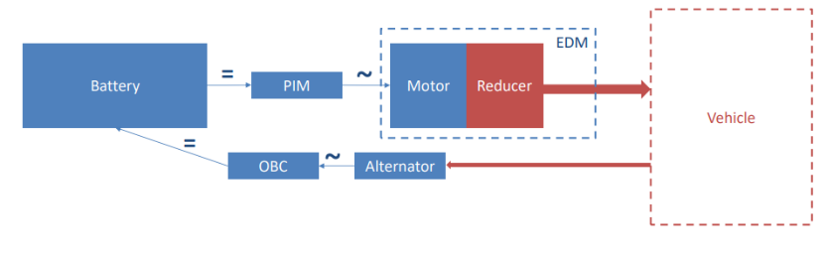The general scheme of a BEV includes **battery**, **motor**/**generator** and **transmission**; in a hybrid car both a **motor** and an **engine** are present, as well as a **battery** and a **fuel tank**. The main **components** of a BEV are:

* **Battery**: it generates energy;
* **Power Inverter Motor PIM**: it transforms the **direct current** generated by the battery to **alternating** **current**;
* **Electric Drive Motor EDM**: it replaces the traditional powertrain and includes an eMOTOR and a **reducer**;
* **Alternator**: it transforms the **alternating current** generated by **braking** into **direct current** to recharge the battery;
* **On-Board Charger**: it includes the **plug-in system** to recharge the battery.

These components are divided into **two** **groups**: the **battery system**, that includes the **battery** and its **charger**, and the **electric drive module**, that includes, the **power electronic**, the **eMOTOR** and the **reducer**.

***Electric Drive Motor EDM***

The EDM follows a **3 in 1 archetype**: inverter, reducer and eMotor are managed as a **single component**, meaning that every piece is **designed**, **manufactured**, **assembled** and **tested** in **same plant** and then **shipped** to the **vehicle assembly plant**. This management method is the **evolution** of the **2 in 1 archetype** (which focused reducer and eMOTOR). The **main trends** in this field are:

* The **X in 1 archetype**;
* The **Rare Earth Elements REE and HREE Free EDM** with lowest **Global Warming Potential GWP** as an **alternative** to **Permanent Magnet Synchronous Motor PMSM**. As a matter of fact, more than **90%** of rare earths is used in the **eMOTOR**.

**ELEMENTS OF MANUFACTURING MANAGEMENT**

***The basics of management***

The essence of management is **plan**, **budget** and **forecast**; forecast is a **prediction**, while budget is all the **measures** a company is willing to take in order to **improve** the result based on a forecast.

A project or a system are **under control** not when they don’t variate, but when their variations are so **small** that they can be **corrected** before suffering any consequences; consequently, a project or a system are **managed** when all their parameters are **under control**. Ultimately, the **essence** of management is to make a budget and keep it under control through **periodic checkpoints** with **deviation analysis** and **corrective** **actions**. Sensitivity analysis is an **evaluation** of the influence that alle the possible parameters give to a result; mathematically, the result is a function of **many variables** and sensitivity analysis studies its **derivatives**.

**INTRODUCTION TO BATTERIES**

***Definition***

A battery is a device that **converts** chemical energy into electric energy through a **redox reaction** of its active materials. Batteries have a **Russian dolls-like structure**; from bottom the inside to the outside we have:

* **Cells**: it’s the **elementary unit** and it’s where all the chemistry happens, so it defines the **voltage** and the **capacity** of the whole battery;
* **Module**: it’s made up of **cells connected** in series or parallel and it’s where the **electronic** (BMS slave) is located, so it’s responsible for **signal monitoring** and **HV**;
* **Battery pack**: it’s made up of **modules** and their signals;
* **Battery system**: it’s made up of **battery packs**, **electronic management** (BMS master), **HV** **distribution**, **cooling** and **heating** **system** and **external** **connectors**.

***Battery cells***

**STRUCTURE**

A cell is the **electrochemical unit** used to generate or store electric energy. it’s made up by **three main parts**:

* **Cathode**: it contains the **cathodic paste**, composed of a various mixtures of **metal oxides**, and the cathodic **current collector**, an **aluminum tape** as wide as the cell;
* **Anode**: it contains the **anodic paste**, mainly composed of **graphite**, and the anodic **current collector**, a **copper tape** as wide as the cell;
* **Porous separator**: it’s a **plastic tape** that separates the two areas both mechanically and electrically.

Both the anode and the cathode are immerged in an **electrolyte**, an **organic-based liquid**.

**CATHODE CHEMISTRY**

While the anode always contains graphite, the cathode can contain **different compounds** according to the expected performance. Besides cobalt, which is the most expensive material, we can have:

* **NMC 811 or NCA+**: they are the most common chemicals for **cars**;
* **LFP**: it’s the **cheapest** and **safest** compound, but it has **lower performances** than NMC and NCA.

***Cells performances evaluation***

Battery cells and their chemistries are evaluated on the basis of **5 criteria**:

* **Specific energy**: it’s the **ratio** between the **amount of energy** contained and the **weight** of the battery. Its measure is $\left[\frac{Wh}{kg}\right]$, being $Wh=V⋅Ah$;
* **Safety**: it depends on how **thermally stable** the components are;
* **C-rate**: the **charge/discharge** **rate**, it is linked to the cell’s ability to generate power;
* **Life cycle**: it’s the **number of times a** cell can be charged and discharged, normally considered when **80% residual capacity** is reached;
* **Cost**.

**POWER AND ENERGY**

Batteries of the same chemistry can be optimized for **power density** or **energy density**, resulting in a **higher C-rate** or a **lower C-rate** respectively:

* **Power**: this type of batteries accepts **fast charges/discharge**, so their cells have **more active material** (paste);
* **Capacity**: this type of batteries delivers **less currents** but focuses on storing **more energy**, so their cells have **thicker metal collectors**.

***Cells types***

Cells classification is based on their **shape**:

* **Prismatic (metal can)**: it’s **easy** to **integrate**, **cool**/**heat** and needs **minimum mechanical support**, but it’s **very expensive** in terms of manufacturing and is sensitive to uneven pressures;
* **Cylindrical (metal can)**: it’s **easy** and **cheap** **to** **manufacture** and has a **flexible** module design, but it’s **difficult** to **heat**/**cool** and may suffer from uneven pressure and temperature;
* **Pouch (vacuum-sealed metalized plastic bag)**: it’s cheap and **flexible to manufacture** and optimized for weight, performance and cost, but it is sensitive to **internal gassing** and mechanic stress.

**STRUCTURE OF A PRISMATIC CELL**

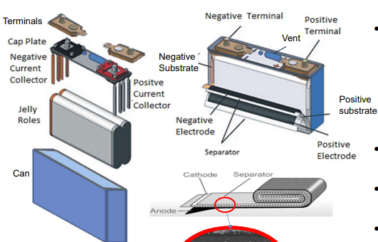Electrodes are placed “**jelly-rolled**” in an aluminum can, which is **insulated** with PET tape or paint and then sealed with **laser welding**; the electrolyte is added via **filling**. It has several **safety features**:

* Pressure release and gas removal are guaranteed through a **vent**;
* It has a **fuse** and **overcharge protection device**;
* The can provides **rigidity** to the structure and a **hermetic** environment.

**CELLS, MODULES AND BATTERY PACK PROCESS**

***The complete supply chain***

The battery supply chain is divided in several steps:

* **Raw material mining**: the raw materials are **extracted** following some **environmental** and **social** **criteria**, like non-use of nickel from mines that dump their tailings at sea or non-use of cobalt from artisanal mines in the Democratic Republic of Congo;
* **Refining**: the raw materials are **refined** and transformed first into **powder** and then into **value-added products** (like lithium carbonate or lithium hydroxide);
* **Slurry mixing**: the products necessary for the preparation of the **slurries** (active material, conductive material, dissolved binder and solvent) are introduces into dedicated **mixers**, both for the cathode and the anode;
* **Coating**: the ink is applied to an **aluminum** **foil** for the cathode and to a **copper** **foil** for the anode. The foil is continuously transferred into a **dryer** to evaporate solvents and water;
* **Calendering**: copper and aluminum foils are **compressed** by **rotating** **rollers**, which define a precise **thickness** thanks to a specific pressure;
* **Laser notching and slitting**: the strip coils are **notched** on their edge as to cut out the **ears** of each electrode. The strip is **slit** on its axis to obtain the desired width;
* **Stacking**: the separated electrode sheets are **stacked** in a repeating cycle of **anode-separator-cathode-separator** (one of the most used technologies is the Z-folding);
* **Laser and ultrasonic welding and cell assembly**: welding is used to **fix the lugs** together, join the stacks in **pairs** and solder the stacks to copper or aluminum connectors, which are themselves **soldered** to the cell cover. This stack is then inserted into a **prismatic can** and the cover is **welded** around its periphery. The assembly is subsequently **closed** by a temporary cap;
* **Baking and filling**: the last traces of **moisture** are removed with a **drying** **process** and then the electrolyte is **inserted** into the cell;
* **Electric formation**: it’s the first **charging and discharging process**, realized through **contact pins**. This process is **repeated** several times before the cell is hermetically sealed;
* **Module assembly**: the cells that have passed all the **validation phases** are **connected** to each other, which are then **combined** into modules;
* **Battery assembly and integration in the vehicle**: after being tested, the modules are sent to **battery** **pack** manufacturers, where they are **assembled** according to technical, environmental and safety specifications. Eventually, they are integrated into **vehicles**;
* **Recovery/recycling**: at the end of their lives, batteries are **retrieved** from the vehicles and **repaired** or **dismantled** and **recycled**.

**ECONOMICS AND EVOLUTION**

***Cell-to-Pack CTP evolution***

Pack designs are evolving towards a **monolithic design**, with the purpose of eliminating **dead weight** and enable higher **packing efficiency**. As a matter of fact, eliminating the **module assembly** level reduces the **assembly cost** and increase the packing efficiency; however, there are some major issues regarding safety and thermal propagation, that are yet to be overcome.

***Forecast of production evolution***

Currently, cells are assembled together in modules, but this is the path companies are trying to pursue:

* **Cell block**: it’s similar to a module, but **bigger** and with specific **size**, **dimension** and **number of cells**, each of which are **adapted** to the pack in order to increase efficiency;
* **Cell to pack**: cells are **directly** **integrated** into the battery pack without a preassembly level (no module or cellblock), so they are **glued** on by one;
* **Cell to body**: it aims to an **integration** between pack housing and body in white, through **communalization** of pack cover and car floor and of rocker and pack side profile.

**VEHICLE MANUFACTURING**

***Processes and manufacturing***

A **process** is a **systematic series** of mechanized or chemical operations performed in order to **produce** something, while **manufacturing** is the **process** of converting raw material, parts or components into finished goods; it usually employs a man-machine setup. Here are the manufacturing processes for a vehicle:

* **Stamping**: it includes a variety of **sheet-metal forming**, like bending or blanking. It’s a capital-intensive area with a **high productive rate**;
* **Welding (Body in White)**: it consists in **welding together** the sheet metal **components** of the car **body** and it includes gluing, riveting and tightening. It’s a capital-intensive area with a lot of **flexibility** over platforms and models;
* **Paint**: it’s a process during which bodies are **cleaned** and covered in layers of **chemicals** and **pigments**, so as to **protect** surfaces and provide the **final color**. It’s **water-based** and it grants full **color flexibility**;
* **Plastic shop**: it includes a variety of **polymeric processes** like stamping, extrusion, blowing and forming;
* **General assembly**: it’s the process in which parts are **added in sequence** from workstation to workstation until the final assembly is **completed**, and it includes **testing** and **final** **certification**.

Between stamping and welding and between welding and paint, vehicles are inspected inside the so-called **quality centers**: it’s where **measuring** and part **testing** are performed in order to grant **geometry consistency** and product and process **conformity**.

***Digital manufacturing validation***

**PLANNING**

It includes different phases:

* **Building modeling**: through **laser scanning technology**, facility managers are able to quickly **capture** the very complex **geometry** of buildings as well as their **assets**, like machinery and power components;
* **Feasibility analysis**: it includes a series of **verifications** regarding safety, ergonomics and quality performance as is performed by **simulating** the workplace with **3D modeling**;
* **3D layout and line configurator**: the latter is a tool that’s sketches **new production lines** in 3D;
* **Throughput simulation**: it’s a tool that **predicts plant performance** and sizes key manufacturing planning inputs (like cycle times or buffer strategies). It also helps to identify **wastes**, losses and **bottlenecks**.

**DESIGN AND BUILD**

It includes different phases:

* **Virtual Design Reviews VDR and ergonomics**: VDR allows to **validate** at an early stage the **design** of machinery, equipment and layouts, in order to **optimize** the design in accordance with products standards, quality targets and so on. Ergonomics simulation allow to evaluate **human factors** related to production tasks;
* **ImMErsive Technology**: thanks to **virtual reality devices**, different **scenarios** can be evaluated, manufacturing plants explored, products and process feasibility analysis performed, and so on;
* **Digital cross sheets**: they integrate all the information required to **draft** or **modify** a production line in a single environment;
* **Offline programming**: it’s a **robot programming method** performed by a robot program created through a **graphical 3D model**;
* **Virtual commissioning**: it allows to **validate** the real control systems in order to improve the simulation of **automatic stations**.

**FOOTPRINT EVOLUTION**

***What is a footprint***

The footprint of a company shows a **geographic distribution** of its facilities, mainly its **production plants** and, sometimes, its **engineering center**; it can also indicate the allocations of the **main products** and sometimes the **production capacity**. The **official** footprints show only the **current status** of the company, while the **work** versions also show the **evolution** of the plant, like their **planned transfer**.

***Footprint management***

In the past, the golden footprint rule was “two products in a plant, two plans for a product”:

* Two products in a plant allowed the company to **compensate** the downs of one of them with the production of the other one;
* In order to face issues properly, it’s better two have two **different plants** producing the **same product**.

However, this rule did not allow companies to pursue the goal of **carbon neutrality** and minimize **logistic** **impact**, so nowadays is less used than before.

**THE PHASE IN-PHASE OUT PROBLEM**

It is one of the **major issues** of a footprint; when replacing an old product, it’s impossible not to have both the products to **overlap**: there will always be a period of time when they are being produced at the **same** **time**. As a matter of fact:

* The dismantling process takes at least three months;
* It takes also at least three months to refurnish the plant;
* Installation, retooling and product validation take at least nine months in total.

**THE ELECTRICAL TRANSITION**

The **transition** from ICE to electric engine is an example of phase in-phase out problem, but it’s so **complex** and **disruptive** that it can’t be treated with **usual procedures**, but with a gradu**al transformation** of the footprint.